31.16: a)

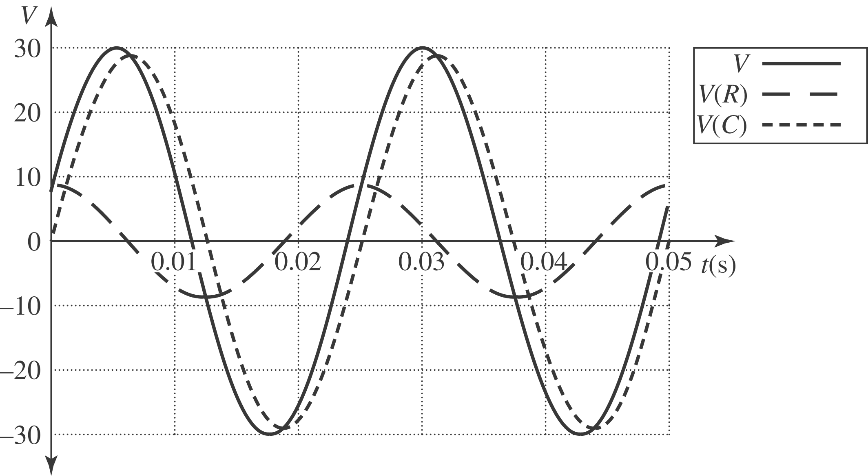

b) The different voltage are:
c) Careful with radians vs. degrees!

